Syllabus for Spanish Classes - Alba
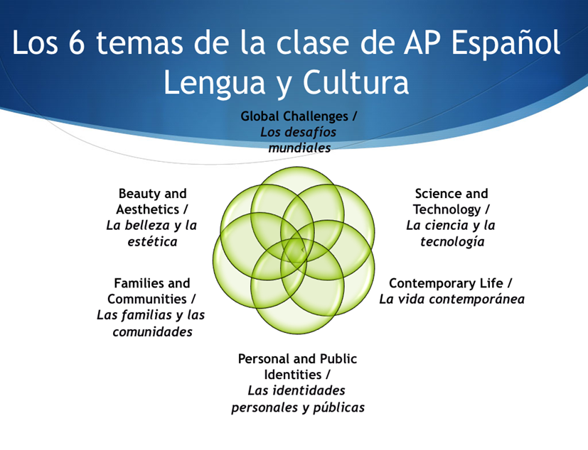

Pre-AP Spanish II Advanced & Spanish III Pre-AP/Spanish 4 AP
Grade: 7th → Pre-AP Spanish II Advanced
Prerequisite Course(s): Spanish I Pre-AP Advanced; teacher approval
Pre-AP Spanish II Advanced emphasizes Spanish language, advanced grammar, and oral proficiency. Students are expected to have a command of oral Spanish. Use of AP Spanish language materials, listening comprehension drills, and creative speaking activities are emphasized to prepare the student to take the AP Spanish Language and Culture Exam in the 8th grade.

Grade: 8th → Spanish III Pre-AP/Spanish 4 AP
Prerequisite Course(s): Pre-AP Spanish II Advanced; teacher approval
Spanish III Pre-AP/Spanish 4 AP emphasizes Spanish language, advanced grammar, and oral proficiency. Students are expected to have a command of oral Spanish. Use of AP Spanish language materials, listening comprehension drills, and creative speaking activities are emphasized to prepare the student to take the AP Spanish Language and Culture Exam. Scoring a 3 or above on the AP Exam will allow the student to receive some college credit depending on the individual college’s policy. Each college will determine how the college hours are transferred so the student needs to contact the admission office at the school he/she would like to attend. This information can also be obtained on college websites.
Textbook Name: Abriendo Paso-Temas y Lecturas
https://reader.savvasrealize.com/#/login

Texas Middle School Program for AP Spanish
https://tea.texas.gov/sites/default/files/AP_Spanish_MidSchool_Accessible%20Version.pdf
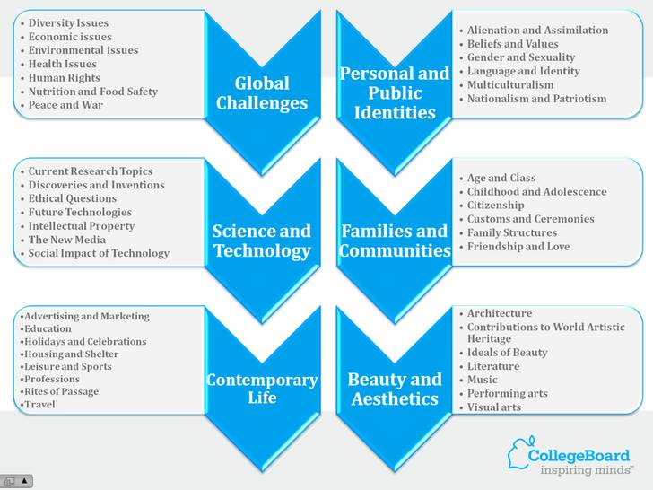

https://apstudents.collegeboard.org/
https://myap.collegeboard.org/login
Grade: 7th & 8th → Spanish I
The Spanish I Course is an introduction to the study of the target language and its culture. This course allows students to explore the Spanish-speaking world through cultural readings, songs, and videos. The student learns the beginnings of the Spanish language structure built around a basic working vocabulary. Grammar is integrated throughout the course and is selected according to the language needs. The emphasis is placed on the development of the four skills listening, speaking, reading and writing within a given context extending outside of the classroom setting when possible. The context focuses on the students’ lives and experiences. It includes an exposure to everyday customs and lifestyles. Students acquire some insight into how languages and cultures work by comparing the target language and culture(s) to their own.

Course Goals: To give the students the opportunity to achieve the ability to communicate in another language, to expand student’s understanding of the target language, its people and culture, and to raise student’s awareness of cultural diversity in order to better comprehend one’s own.

Textbook Name: Auténtico 1
https://reader.savvasrealize.com/#/login

Foreign Languages Resources
https://www.cisd.org/Page/8353

EXPECTATIONS
https://cisd.instructure.com/courses/14637/pages/course-expectations
● Electronic devices are to be put away during class.
● Put forth your best effort.
● Be proactive with your learning.
● Listen to directions.
● Speak as much ESPAÑOL as possible!
● Attend class daily PREPARED with writing utensils, notebook,
and folder.
● Enthusiastically contribute to class activities EVERY DAY not
only by raising your hand to volunteer answers, but also
actively working during group work and staying on task.
● RESPECT each other’s individuality, privacy, and differences.
● Act respectfully and appropriately during class.
● Find out what you missed and make it up promptly.
● Communicate regularly with the teacher, especially if
having difficulties.

ABSENCE POLICY, ACADEMY HONESTY, HOMEWORK
See student handbook. Additional Information Regarding Academic Honesty Unless otherwise stated by the teacher, all assignments are to be turned in and completed independently. The consequences of cheating are cumulative and will be taken to the principal.

